**Koneru Lakshmaiah Education Foundation**

**(Deemed to be University)**

**FRESHMAN ENGINEERING DEPARTMENT**

**A Project Based Lab Report**

**On**

**MAYOR’S RACE**

**SUBMITTED BY:**

I.D NUMBER NAME

180030166 KARTISH.J

**UNDER THE GUIDANCE OF**

**Mr. Kumar Dorti**

**Asst. Professor**



**KL UNIVERSITY**

Green fields, Vaddeswaram – 522 502

Guntur Dt., AP, India.

**DEPARTMENT OF BASIC ENGINEERING SCIENCES-1**



**CERTIFICATE**

This is to certify that the project based laboratory report entitled “MAYOR’S RACE” submitted by Mr./Ms**. KARTISH** bearing Regd. No. 180030166 to the **Department of Basic Engineering Sciences-1, KL University** in partial fulfillment of the requirements for the completion of a project based Laboratory in “TECHNICAL SKILLS-1(CODING)”course in I B Tech I Semester, is a bonafide record of the work carried out by him/her under my supervision during the academic year 2018 – 2019.

PROJECT SUPERVISOR HEAD OF THE DEPARTMENT

Mr. KUMAR DORTI Dr. L. SRIDHARA RAO

**ACKNOWLEDGEMENTS**

It is great pleasure for me to express my gratitude to our honorable President **Sri. Koneru Satyanarayana**, for giving the opportunity and platform with facilities in accomplishing the project based laboratory report.

I express the sincere gratitude to our principal **Prof Dr. N.Venkataram** for his administration towards our academic growth.

I express sincere gratitude to HOD-BES-1**Dr. L. SridharaRao** for his leadership and constant motivation provided in successful completion of our academic semester. I record it as my privilege to deeply thank for providing us the efficient faculty and facilities to make our ideas into reality.

I express my sincere thanks to our project supervisor Mr. KUMAR DORTI for his/her novel association of ideas, encouragement, appreciation and intellectual zeal which motivated us to venture this project successfully.

Finally, it is pleased to acknowledge the indebtedness to all those who devoted themselves directly or indirectly to make this project report success.

Name Id number

KARTISH 180030166

**ABSTARCT**

This is a project where we are asked to write up a code which would end up giving us an output of the result from Mayor’s Race . Here it is asked to calculate the total number of votes and their respective number of votes for each precinct.

Here we need to compare in the number of votes and their respective percentages of the votes they got. According to the results we are supposed to print the results over few conditions.

And to solve this problem we are soling a topic in C program called else if ladder.

Else if ladder: The If else ladder statement in C programming language is used to test set of conditions in sequence. An If condition is tested only when all previous if conditions in if-else ladder is false. If any of the conditional expression evaluates to true, then it will execute the corresponding code block and exits whole if-else ladder.

And this the way we find out a solution for the given cases.

**INDEX**

|  |  |  |
| --- | --- | --- |
| **S.NO** | **TITLE** | **PAGE NO** |
| 1 | Introduction | 6 |
| 2 | Aim of the Project | 7 |
| 2.1 | Advantages & Disadvantages | 7 |
| 2.2 | Future Implementation | 7 |
| 3 | Software & Hardware Details | 8 |
| 4 | Data Flow Diagram | 9 |
| 5 | Algorithm | 12 |
| 6 | Implementation | 15 |
| 7 | Integration and System Testing | 16 |
| 8 | Conclusion | 19 |

**INTRODUCTION**

C is a procedural programming language. It was initially developed by Dennis Ritchie between 1969 and 1973. It was mainly developed as a system programming language to write operating system. The main features of C language include low-level access to memory, simple set of keywords, and clean style, these features make C language suitable for system programming like operating system or compiler development.  
Many later languages have borrowed syntax/features directly or indirectly from C language. Like syntax of Java, PHP, JavaScript and many other languages is mainly based on C language.

The if else ladder statement in C programming language is used to test set of conditions in sequence. An if condition is tested only when all previous if conditions in if-else ladder is false. If any of the conditional expression evaluates to true, then it will execute the corresponding code block and exits whole if-else ladder.

**AIM**

The results from the mayor's race have been reported by each precinct as follows: Candidate Candidate Candidate Candidate Precinct A B C D 1 192 48 206 37 2 147 90 312 21 3 186 12 121 38 4 114 21 408 39 5 267 13 382 29 Write a program to do the following:

a. Read the raw vote totals from a data file that contains one row for each precinct.

b. Display the table with appropriate headings for the rows and columns.

c. Compute and display the total number of votes received by each candidate and the percent of the total votes cast.

d. If any one candidate received over 50% of the votes, the program should print a message declaring that candidate the winner.

e. If no candidate received 50% of the votes, the program should print a message declaring a run-off between the two candidates receiving the highest number of votes; the two candidates should be identified by their letter names.

f. For testing, run the program with the above data, and also with another data file where candidate c receives only 108 votes in precinct 4.

**Advantages:-** the major advantage of these statements is that they allow you to do programming! It is hard and often impractical to try and code without them…

**Disadvantages:-**

**Future enhancements:-**

Switch statement and if else controls are most important decision making constructs for any programming language. Almost every program requires including any of these two statements. In certain conditions if else wins over switch, where in other condition later appears performing better than earlier.

**SYSTEM REQUIREMENTS**

* **SOFTWARE REQUIREMENTS:**

The major software requirements of the project are as follows:

Language : Turbo-C

Operating system**:** Windows Xp or later.

* **HARDWARE REQUIREMENTS:**

The hardware requirements that map towards the software are as follows:

RAM : 8 gb

Processor : Intel

**DATA FLOW DIAGRAM**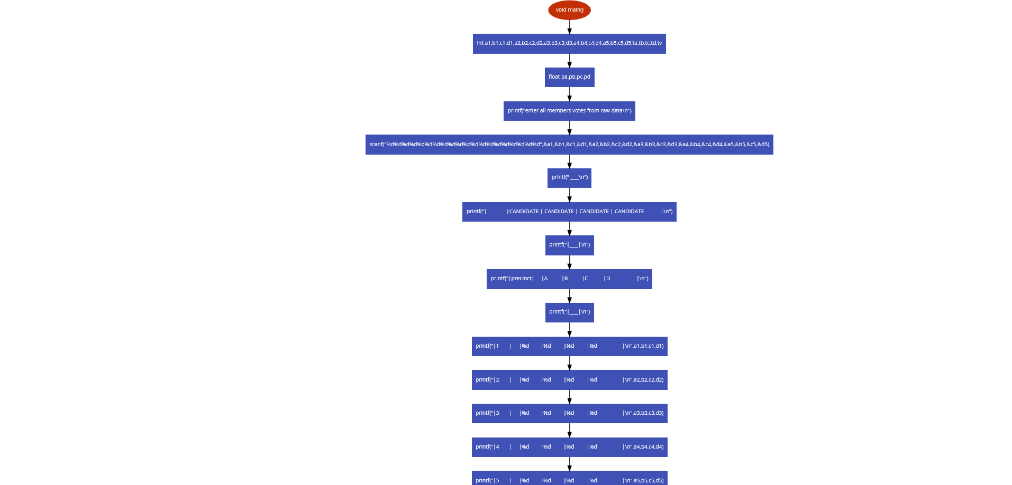

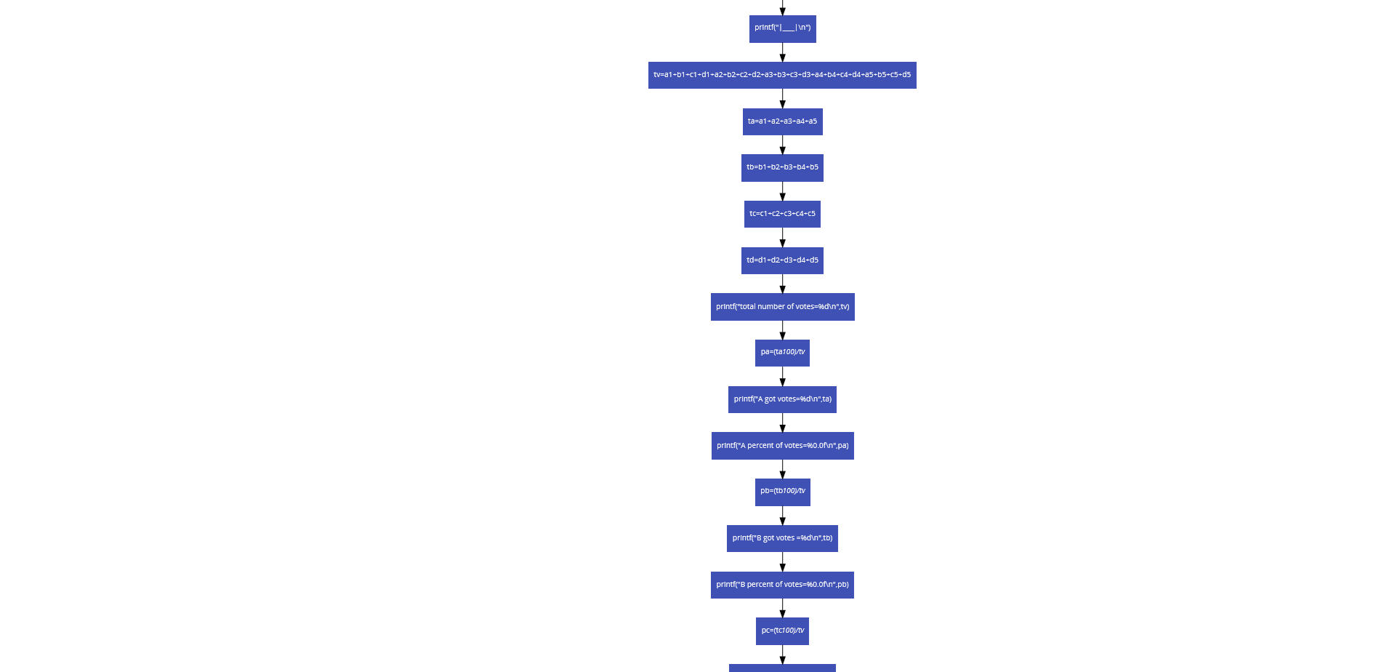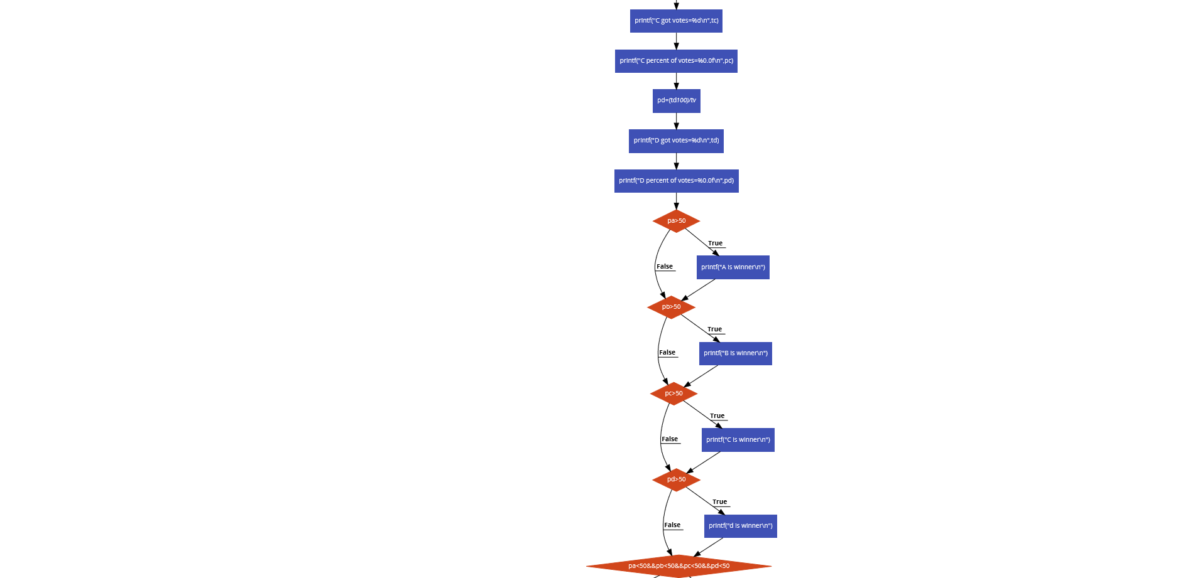

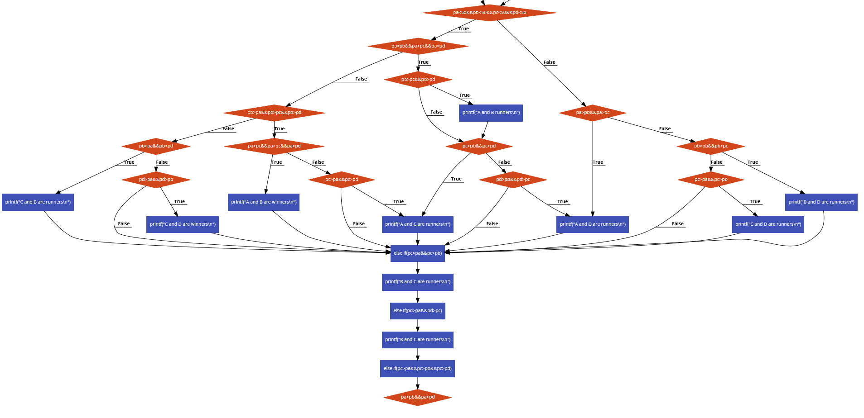

**ALGORITHM**

**STEP 1.Start**

**STEP 2.Read a1,b1,c1,d1,a2,b2,c2,d2,a3,b3,c3,d3,a4,b4,c4,d4,a5,b5,c5,d5,ta,tb,tc,td,tv,pa,pb,pc,pd;**

**STEP 3.tv=a1+b1+c1+d1+a2+b2+c2+d2+a3+b3+c3+d3+a4+b4+c4+d4+a5+b5+c5+d5**

**ta=a1+a2+a3+a4+a5**

**tb=b1+b2+b3+b4+b5**

**tc=c1+c2+c3+c4+c5**

**td=d1+d2+d3+d4+d5**

**STEP 4. print total number of votes**

**pa=(ta*100)/tv**

**STEP 5. print number of votes a got**

**STEP 6. print percentage of votes of a**

**pb=(tb*100)/tv**

**STEP 7. print number of votes b got**

**STEP 8. print percentage of votes of b**

**pc=(tc*100)/tv**

**STEP 9.print number of votes c got**

**STEP 10. print percentage of votes c got**

**pd=(td*100)/tv**

**STEP 11. print number of votes d got**

**STEP 12. print percentage of votes d got**

**STEP 13.if pa>50**

**print a is winner**

**STEP 14. if pb>50**

**print b is winner**

**STEP 15. if pc>50**

**print c is winner**

**STEP 16. if pd>50**

**print d is winner**

**STEP 17. if pa<50 and pb<50 and pc<50 and pd<50**

**STEP 18. if pa >pb and pa>pc and pa>pd**

**if pb>pc and pb>pd**

**print a and c are runners**

**STEP 19. else if pd>pb and pd>pc**

**print a and d are runners**

**STEP 20. else if pb>pa and pb>pc and pb>pd**

**print a and b are winners**

**STEP 21. else if (pc>pa and pc>pd)**

**print b and c are runners**

**STEP 22. else if pd>pa and pd>pc**

**if pa>pb and pa >pd**

**print a and c are runners**

**STEP 23. else if pb>pa and pb>pd**

**print c and b are runners**

**STEP 24. else if pd>pa and pd>pb**

**print c and d are winners**

**STEP 25. else**

**if pa >pb and pa>pc**

**print a and d are runners**

**STEP 26. else if pb>pb and pb>pc**

**print b and d are runners**

**STEP 27. else if pc>pa and pc>pb**

**print c and d are winners**

**IMPLEMENTATION**

#include<stdio.h>

void main()

{

int a1,b1,c1,d1,a2,b2,c2,d2,a3,b3,c3,d3,a4,b4,c4,d4,a5,b5,c5,d5,ta,tb,tc,td,tv;

float pa,pb,pc,pd;

printf("enter all members votes from raw data\n");

scanf("%d%d%d%d%d%d%d%d%d%d%d%d%d%d%d%d%d%d%d%d",&a1,&b1,&c1,&d1,&a2,&b2,&c2,&d2,&a3,&b3,&c3,&d3,&a4,&b4,&c4,&d4,&a5,&b5,&c5,&d5);

printf(" ________________________________________________________________________\n");

printf("|              |CANDIDATE | CANDIDATE | CANDIDATE | CANDIDATE            |\n");

printf("|________________________________________________________________________|\n");

printf("|precinct|     |A          |B          |C           |D                   |\n");

printf("|________________________________________________________________________|\n");

printf("|1       |     |%d        |%d         |%d         |%d                  |\n",a1,b1,c1,d1);

printf("|2       |     |%d        |%d         |%d         |%d                  |\n",a2,b2,c2,d2);

printf("|3       |     |%d        |%d         |%d         |%d                  |\n",a3,b3,c3,d3);

printf("|4       |     |%d        |%d         |%d         |%d                  |\n",a4,b4,c4,d4);

printf("|5       |     |%d        |%d         |%d         |%d                  |\n",a5,b5,c5,d5);

printf("|________________________________________________________________________|\n");

tv=a1+b1+c1+d1+a2+b2+c2+d2+a3+b3+c3+d3+a4+b4+c4+d4+a5+b5+c5+d5;

ta=a1+a2+a3+a4+a5;

tb=b1+b2+b3+b4+b5;

tc=c1+c2+c3+c4+c5;

td=d1+d2+d3+d4+d5;

printf("total number of votes=%d\n",tv);

pa=(ta*100)/tv;

printf("A got votes=%d\n",ta);

printf("A percent of votes=%0.0f\n",pa);

pb=(tb*100)/tv;

printf("B got votes =%d\n",tb);

printf("B percent of votes=%0.0f\n",pb);

pc=(tc*100)/tv;

printf("C got votes=%d\n",tc);

printf("C percent of votes=%0.0f\n",pc);

pd=(td*100)/tv;

printf("D got votes=%d\n",td);

printf("D percent of votes=%0.0f\n",pd);

if(pa>50)

{

printf("A is winner\n");

}

if(pb>50)

{

printf("B is winner\n");

}

if(pc>50)

{

printf("C is winner\n");

}

if(pd>50)

{

printf("d is winner\n");

}

if(pa<50&&pb<50&&pc<50&&pd<50)

{

if(pa>pb&&pa>pc&&pa>pd)

{

if(pb>pc&&pb>pd)

{

printf("A and B runners\n");

}

if(pc>pb&&pc>pd)

{

printf("A and C are runners\n");

}

else if(pd>pb&&pd>pc)

{

printf("A and D are runners\n");

}

}

else if(pb>pa&&pb>pc&&pb>pd)

{

if(pa>pc&&pa>pc&&pa>pd)

{

printf("A and B are winners\n");

}

else if(pc>pa&&pc>pd)

{

printf("B and C are runners\n");

}

else if(pd>pa&&pd>pc)

{

printf("B and C are runners\n");

}

}

else if(pc>pa&&pc

>pb&&pc>pd)

{

if(pa>pb&&pa>pd)

{

printf("A and C are runners\n");

}

else if(pb>pa&&pb>pd)

{

printf("C and B are runners\n");

}

else if(pd>pa&&pd>pb)

{

    printf("C and D are winners\n");

}

}

 else

{

 if(pa>pb&&pa>pc)

{

printf("A and D are runners\n");

}

else if(pb>pb&&pb>pc)

{

printf("B and D are runners\n");

}

else if(pc>pa&&pc>pb)

{

printf("C and D are runners\n");

}

}

}

}

**INTEGRATION AND SYSTEM TESTING**

OUTPUTS

Screen Shots:

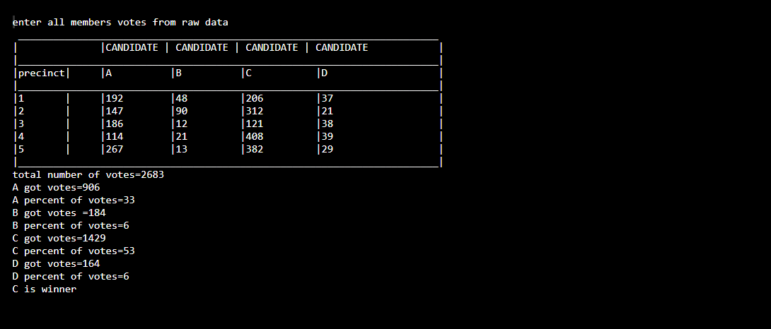

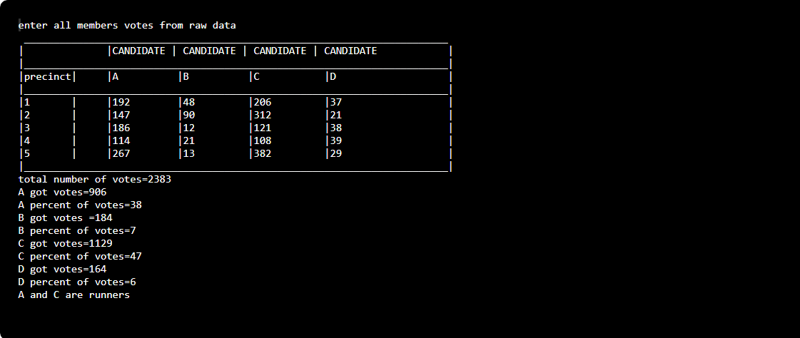

**CONCLUSION**

**By using the process we can fulfill the aim of solving this question by using else if ladder concept. And according the following code we have got an output saying c is winner. Where in the next case it is shown as a and c are runners.**